**SL Unit 2** **– Computer Organization**  
Quiz 1

|  |  |  |  |
| --- | --- | --- | --- |
| **Question 1** | | | |
| Objectives: | 2.1.12 | Exam Reference: | May-16 8 |

Construct the truth table for the following expression.  
  
 A xor (B or C) [3]

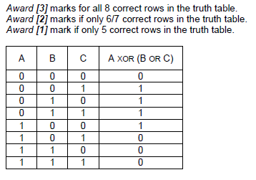

|  |  |  |  |
| --- | --- | --- | --- |
| **Question 2** | | | |
| Objectives: | 2.1.10 | Exam Reference: | May-14 7 |

Outline how a colour can be represented in a computer. [2]

A colour will be split into three components *(Accept RGB as an example)*;

Each component will be assigned a certain number of bytes;

|  |  |  |  |
| --- | --- | --- | --- |
| **Question 3** | | | |
| Objectives: | 2.1.3 | Exam Reference: | May-16 6 |

Describe how the cache memory can speed up the functioning of a processor. [2]

*Award up to* ***[2 max]****.*

Cache memory is closer to CPU/faster to access than main memory/incorporated on the chip;

By holding recently/frequently used data and instructions in cache;

Execution of program/fetching instructions and data is faster;

|  |  |  |  |
| --- | --- | --- | --- |
| **Question 4** | | | |
| Objectives: | 2.1.8 | Exam Reference: | May-14 6 |

Outline, with an example, one benefit of using computer-aided design (CAD) applications. [2]

*Award* ***[1 mark]*** *for an example and* ***[1 mark]*** *for reason of use/functionality, up to*

***[2 marks max]****.*

Support design/layout/development/rapid prototyping in engineering/manufacturing

/biomechanics/architecture;

Save time/costs associated to drawing/development;

Photorealistic rendering/photo simulation in architecture/video games/visual

effects/simulators;

*eg* shading, radiosity, reflection, refraction, illumination for modelling and simulation;

|  |  |  |  |
| --- | --- | --- | --- |
| **Question 5** | | | |
| Objectives: | 2.1.13 | Exam Reference: | Nov-14 6 |

Construct a logic diagram for the Boolean expression

A and B or not B. [3]

